Data modelling and image processing – Individual 2

Aman Bhatia (2338152)
University Canada West
Machine learning
Professor – Abby Gholidoust
Sep 2, 2025

Scope
This assignment includes designing, implementing, and comparing 2 of the machine learning models i.e... recurrent neural network (RNNs) and convolutional neural networks (CNNs) the objective was to classify hand written digits using MINIST dataset. The dataset is a benchmark in computer vision, it contains 70000 grayscale images from digit 0-9, each having size 28*28 pixels. The target is to compare strength and limitation of RNN and CNN architectures in how they handle image classification tasks.

Methodology

Data preprocessing
The dataset was first split into 60000 training images and 10000 test images. For preparing data set for training, following steps were done
- Normalization – pixel values ranging from 0 to 255 were scaled to the range [0,1], this helps for faster convergence during optimization.
- Reshaping – CNN: images were reshaped to (28,28,1), preserving their 2D structure with channel dimension.
RNN: images were reshaped to (28,28), each row of 28 pixels is treated as one time step in a sequence of 28.
- One – hot encoding – target tables (0-9) are converted into categorical vector with 10 classes.
These preprocessing steps makes sure that both models can handle the MNIST data according to their structural requirement.

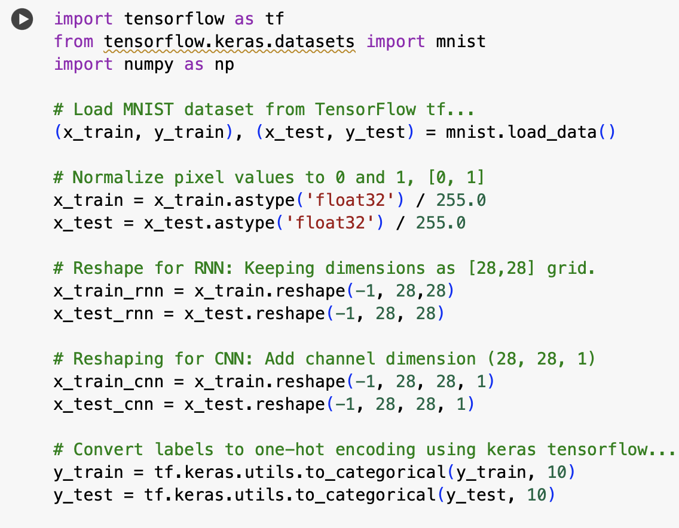

Model implementation

Recurrent Neural Network (RNN)
- Input: (28, 28)
- Layers:
  - SimpleRNN with 128 hidden units
  - Dense (64 units, ReLU)
  - Dense (10 units, Softmax for classification)
- Optimizer: Adam
- Loss Function: Categorical Crossentropy
- Epochs: 10
- Batch Size: 128
The RNN processes shows each image row sequentially, while maintaining a hidden state across all the time steps.
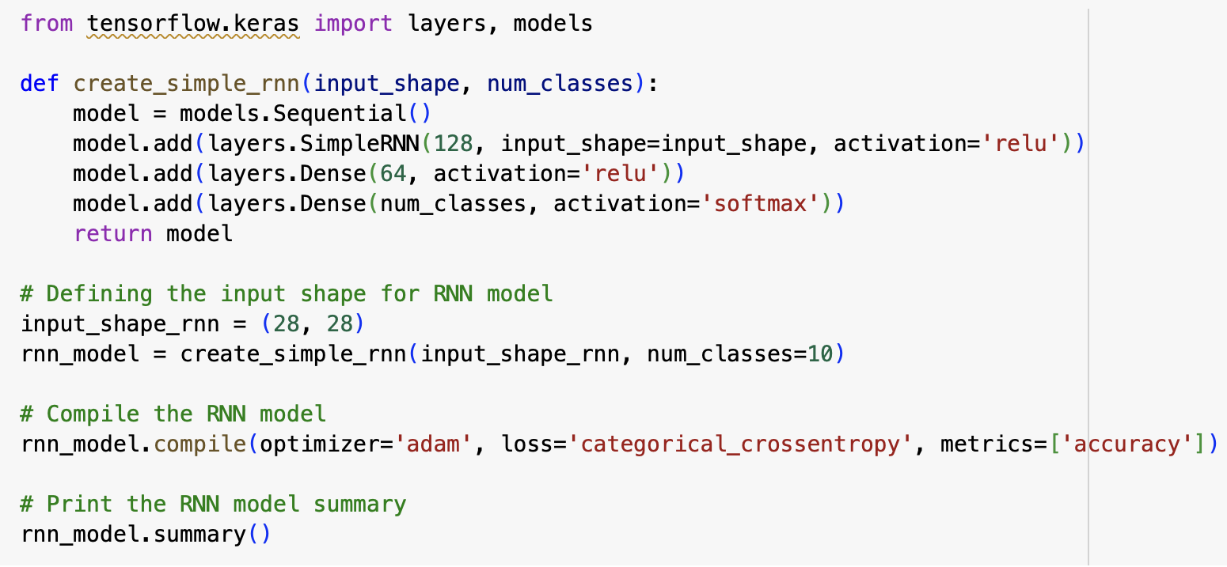

Convolutional Neural Network (CNN)
- Input: (28, 28, 1)
- Layers:
  - Conv2D (32 filters, 3×3, ReLU) + MaxPooling2D
  - Conv2D (64 filters, 3×3, ReLU) + MaxPooling2D
  - Conv2D (64 filters, 3×3, ReLU)
  - Flatten
  - Dense (64 units, ReLU)
  - Dense (10 units, Softmax)
- Optimizer: Adam
- Loss Function: Categorical Crossentropy
- Epochs: 10
- Batch Size: 128
The CNN uses convolutional filters to detect edges, shapes, and digit structures, making it more specialized for image recognition.


Results
Tensor Flow / Keras Results
- RNN Accuracy: 96.95%
- CNN Accuracy: 99.03%

PyTorch Results
- RNN Accuracy: 94.94%
- CNN Accuracy: 99.09%
Visualizations
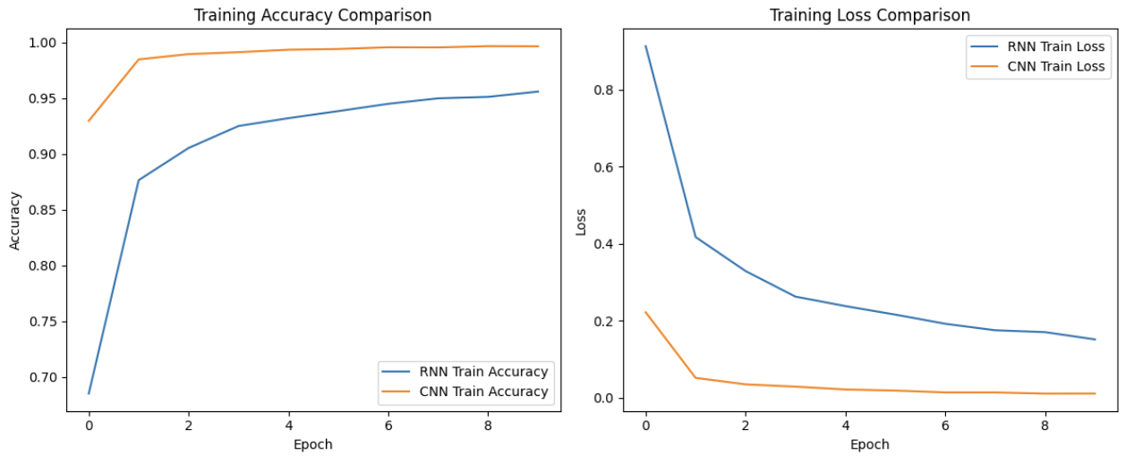

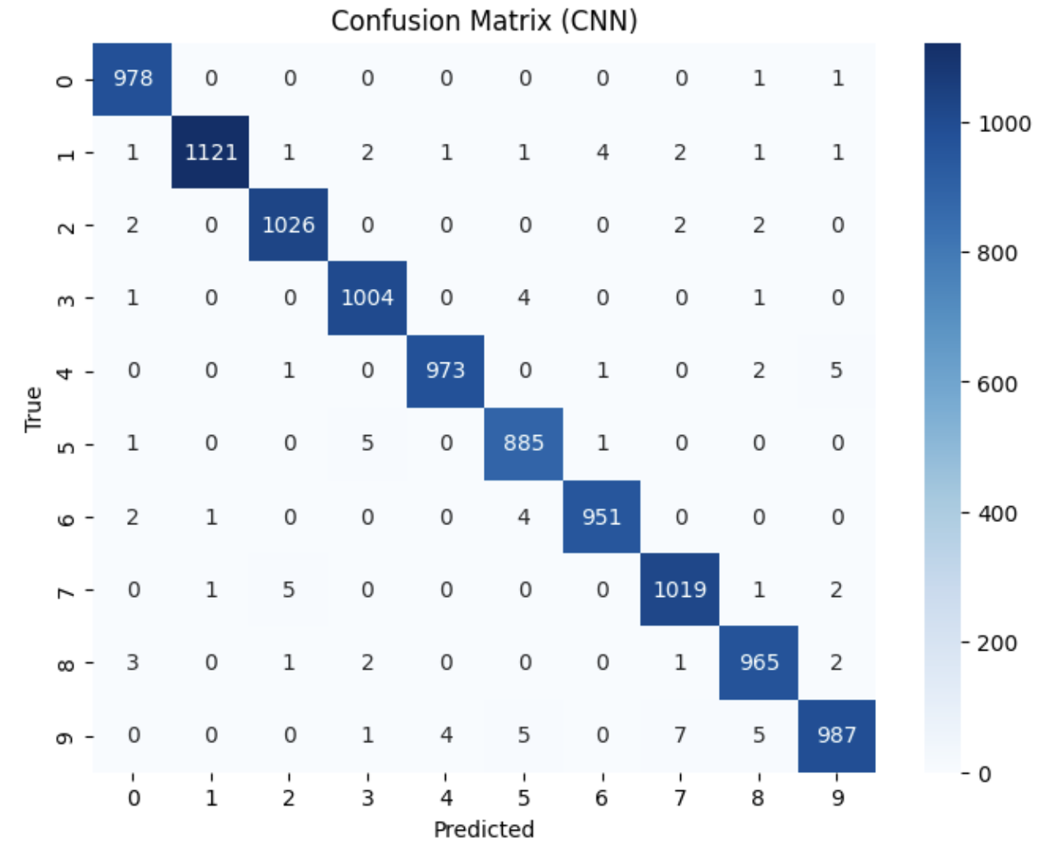

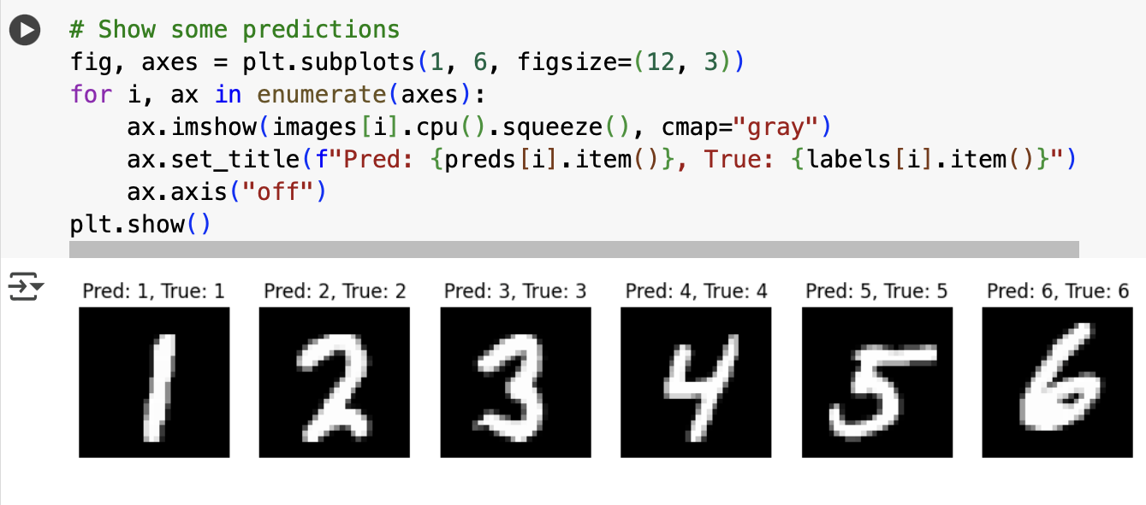

The CNN consistently achieved higher accuracy than the RNN in both frameworks.

Comparison and Analysis
Architectural Suitability
- RNN- Very good for sequential tasks such as text, time-series, or speech, but less suited for images. Treating each row as time step ignore 2d spatial correlations.
- CNN- Designed for spatial data, CNNs capture local features (edges, corners) in early layers and abstract representation in deeper layers.

Performance Differences
- CNN models achieved almost perfect accuracy which is (~99%), while RNNs was stuck at ~95–97%.
- CNN training was more stable, while RNN was having slower convergence and more risk of vanishing gradients.
- Computationally, CNNs required more operations per step but converged faster in practice due to efficient feature learning.
Real world applications
- RNNs is more useful for language processing, handwriting generation, and sequential sensor data.
- CNNs is more effective in image classification, object detection, and computer vision application.
To conclude the comparison CNNs are demonstrably more effective for image related tasks while it leverage spatial structure, hierarchical features, and efficient learning mechanisms. While RNNs, are capable of learning from images when its reshaped into sequences, which lacks the inherent ability to capture 2D spatial relationships.

Conclusion
The experiment confirmed that CNNs are significantly more suitable for image classification that RNNs. While RNNs is more effective on MNIST, they were outperformed by CNNs in both accuracy and learning efficiency. CNNs is capable to capture spatial dependencies made them the superior model for this data set.
This assignment brings out the importance of model and data alignment final verdict would be CNNs are effective and optimal for vision task, while RNNs excels in domains.

References
https://www.tensorflow.org/
https://pytorch.org/
https://colab.research.google.com/drive/1X7KH_Qxh6UP6S8R10ZhqFsU2qFnsUmB7?usp=sharing

